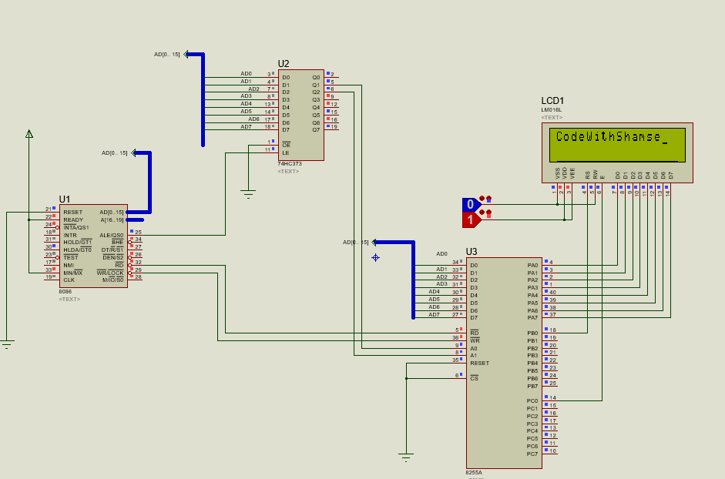

**Program:**

DATA SEGMENT

PORTA EQU 00H ; Port A for data to LCD

PORTB EQU 02H ; Port B (not used in this example)

PORTC EQU 04H ; Port C for control signals

PORT_CON EQU 06H ; Control register for 8255A

DATA ENDS

CODE SEGMENT

ASSUME CS:CODE, DS:DATA

START:

MOV AX, DATA

MOV DS, AX ; Load Data Segment

; Initialize 8255A control word for LCD operation

MOV DX, PORT_CON

MOV AL, 10000000B ; Control word to set 8255A mode

OUT DX, AL

; Initialize LCD (8-bit mode, display on, cursor off)

; LCD Command for 8-bit, 2-line mode, and 5x8 dots

MOV AL, 38H

CALL LCD_CMD

; LCD Command to turn on display and cursor

MOV AL, 0CH

CALL LCD_CMD

; LCD Command to clear display

MOV AL, 01H

CALL LCD_CMD

; Send "Hello" to the LCD

MOV AL, 'H'

CALL LCD_DATA

MOV AL, 'E'

CALL LCD_DATA

MOV AL, 'L'

CALL LCD_DATA

MOV AL, 'L'

CALL LCD_DATA

MOV AL, 'O'

CALL LCD_DATA

; End of Program

HLT

; Subroutine to send command to LCD

LCD_CMD PROC

MOV DX, PORTA

OUT DX, AL ; Send command to PORTA

MOV AL, 04H ; Enable pulse to latch command

MOV DX, PORTC

OUT DX, AL

MOV AL, 00H ; Disable pulse

OUT DX, AL

CALL DELAY

RET

LCD_CMD ENDP

; Subroutine to send data to LCD

LCD_DATA PROC

MOV DX, PORTA

OUT DX, AL ; Send data to PORTA

MOV AL, 05H ; Enable pulse to latch data

MOV DX, PORTC

OUT DX, AL

MOV AL, 01H ; Disable pulse

OUT DX, AL

CALL DELAY

RET

LCD_DATA ENDP

; Delay Subroutine

DELAY PROC

MOV CX, 00FFH ; Simple delay loop

DelayLoop:

LOOP DelayLoop

RET

DELAY ENDP

CODE ENDS

END START